1. 測試內容：

測試 Flow 之instructions “L2MODIFICATION”是否正確運行。

1. 測試環境架構：

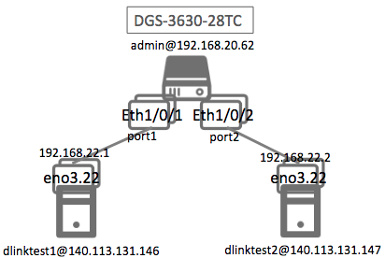

1. 測試環境組態：

* SDN controller: ONOS 1.15.0
* Switch: DGS-3630
* Hosts:
  + ubuntu 16.04.5 LTS
  + dlinktest1(實體機)
    - IP: 192.168.22.1
    - MAC: d0:94:66:5d:5e:08/64
    - Port: 1
  + dlinktest2(實體機)
    - IP: 192.168.22.2
    - MAC: d0:94:66:5c:45:20/64
    - Port: 2
* Apps:

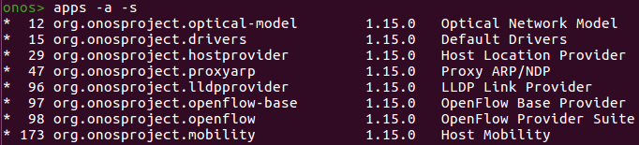

1. 使用之JSON文件：

* Flow Rule: (附檔：L2MODFICATION.json)

|  |
| --- |
| {  "flows": [  {  "priority": 10000,  "timeout": 0,  "isPermanent": true,  "deviceId": "of:000078321bdf4000",  "treatment": {  "instructions": [  {  "type": "L2MODIFICATION",  "subtype": "ETH_DST",  "mac": "FF:FF:FF:FF:FF:FF"  },  {  "type": "OUTPUT",  "port": "2"  }  ]  },  "selector": {  "criteria": [  {  "type": "IN_PORT",  "port": "1"  }  ]  }  }  ]  } |

1. 測試步驟：
2. Switch GUI:

|  |
| --- |
| Switch# show openflow flow |

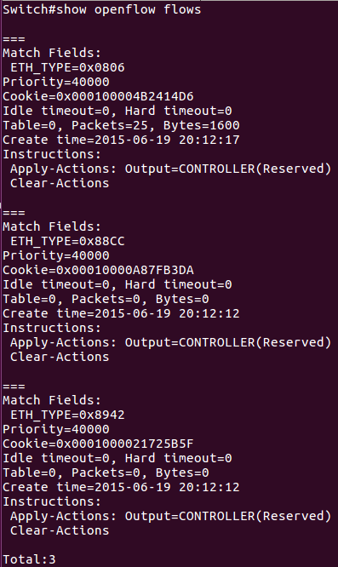

Flow rule 沒有被加到switch。

1. ONOS GUI: Flow View



顯示Pedding Add。

1. ONOS CLI Log:

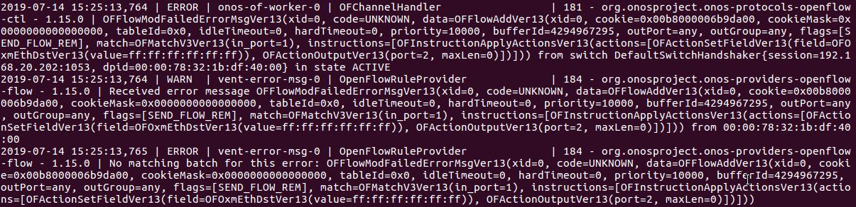

1. 測試結果：

Flow之instructions:“L2MODIFICATION”無法正確運行。